
Wedness day, June 27 2012

“Manmohan Singh to visit Puducherry on June 29-30”

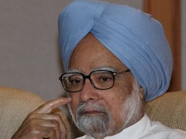.

Puducherry: Prime Minister Manmohan Singh will arrive here on June 29 on a two-day visit to the Union Territory. Singh would attend a function in the Pondicherry University on June 29 and on the next day visit the Aurobindo Ashram and participate in the convocation of premier medical institution JIPMER here, official sources said on Wednesday.

After arriving here by helicopter from Chennai, Singh, on his first visit to the former French colony, would proceed to the Pondicherry University and dedicate to the nation the Madanjeet Singh Institute of South Asia Regional Cooperation.

On June 30, he would visit the 86-year old Aurobindo Ashram and pay homage at the `samadhis` (memorials) of Sri Aurobindo and his spiritual collaborator The Mother.

The Prime Minister would also visit the room where Sri Aurobindo carried out his spiritual experiments for several years.

Sri Aurobindo died in December, 1950, while The Mother (Mirra Alfasa) passed away in November 1973.

After the visit to the ashram, Singh would attend the third convocation of JIPMER (Jawaharlal Institute of Postgraduate Medical Education and Research) since it became autonomous.

JIPMER became an "institution of national importance" through an Act of Parliament in 2008 although it had been functioning since inception in 1950s under the Union Health Ministry.

The Prime Minister would also declare open the Jipmer Academic Centre, Children and women care hospital and a hostel complex built at a total cost of Rs 342 crores, a JIPMER press release said.

